**Web Development Assignment**

**Ice-cream & Cakeshop Website**

**Objective of Web Development Assignment**

We were assigned to develop a web application that interacts with a database via Node.js and that includes an authentication mechanism. The application will implement the four CRUD operations. Some of the requirements that I have to add are:

* Sign In/Sign Up using CRUD with personal information, including a profile pic and password management (change or recovery)
* Authentication: Log In and Log Out
* Search with built in functionalities like: Views, Filters, etc

**Plan for Website**

We wanted to create a website that we felt that everyone could enjoy and what better than ice-cream and cake! Picture the scene, it is a hot summer’s day and you want something nice to cool you down…. introducing VE Ice-Cream and CakeShop Website! Where we will guarantee you, you will find a sweet surprise from our wide range of beautiful desserts!

Low Fidelity:

This was our very very basic sketches of an idea for our website. This was created using paper and pencil.

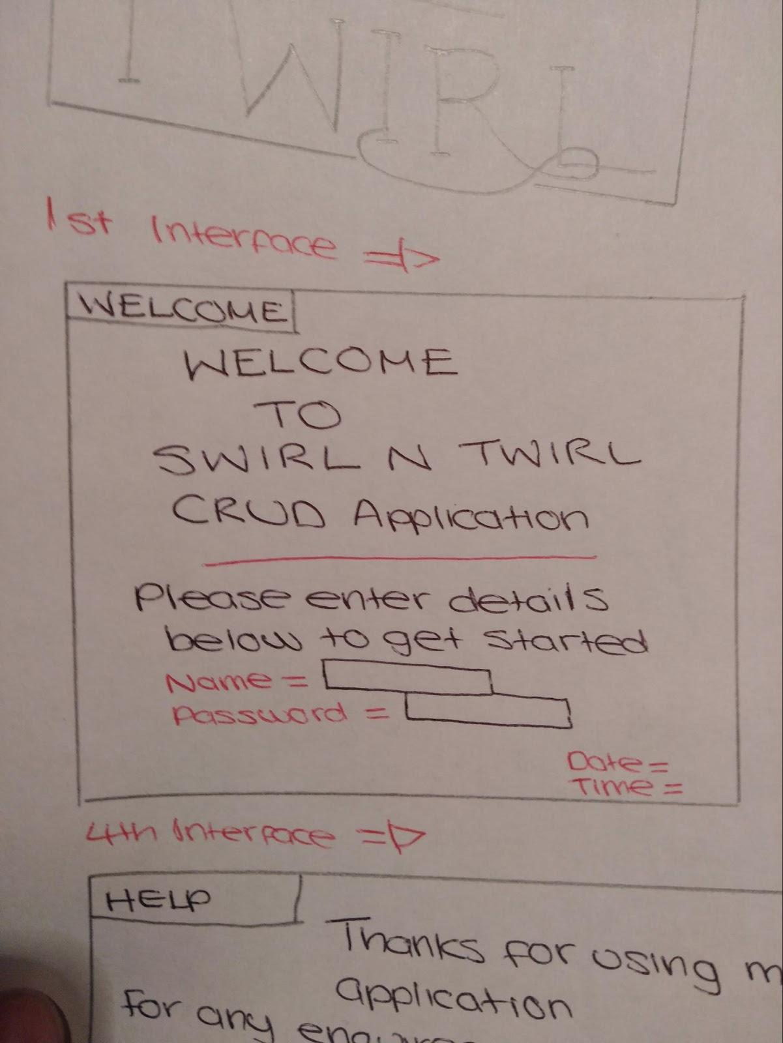

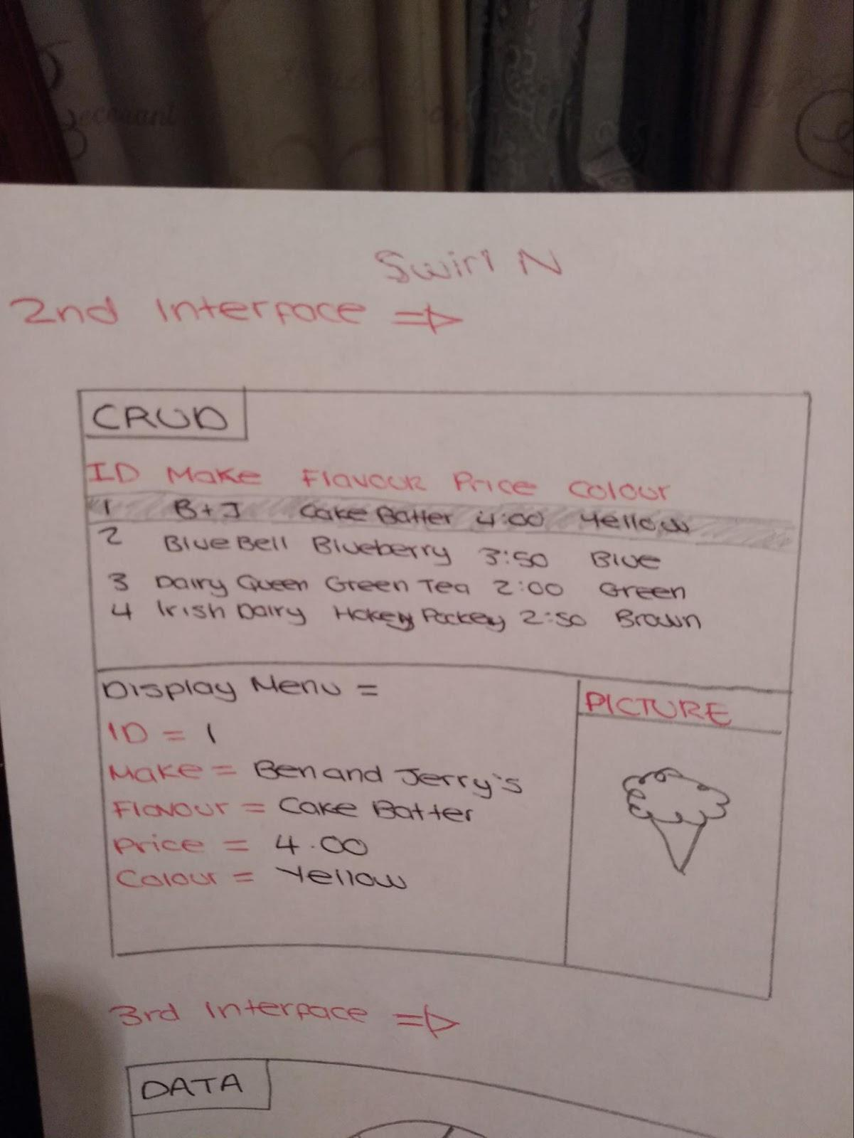

Medium Fidelity:

Using paint we created a rough sketch or idea that we wanted for our website. This was to give us a nice feel for the UI and what sort of color scheme we would go for. We opted for a nice “soft colour look”. An aesthetically beautiful colour contrast between our main primaries baby blue, pastel pink and a light-sunflower yellow.

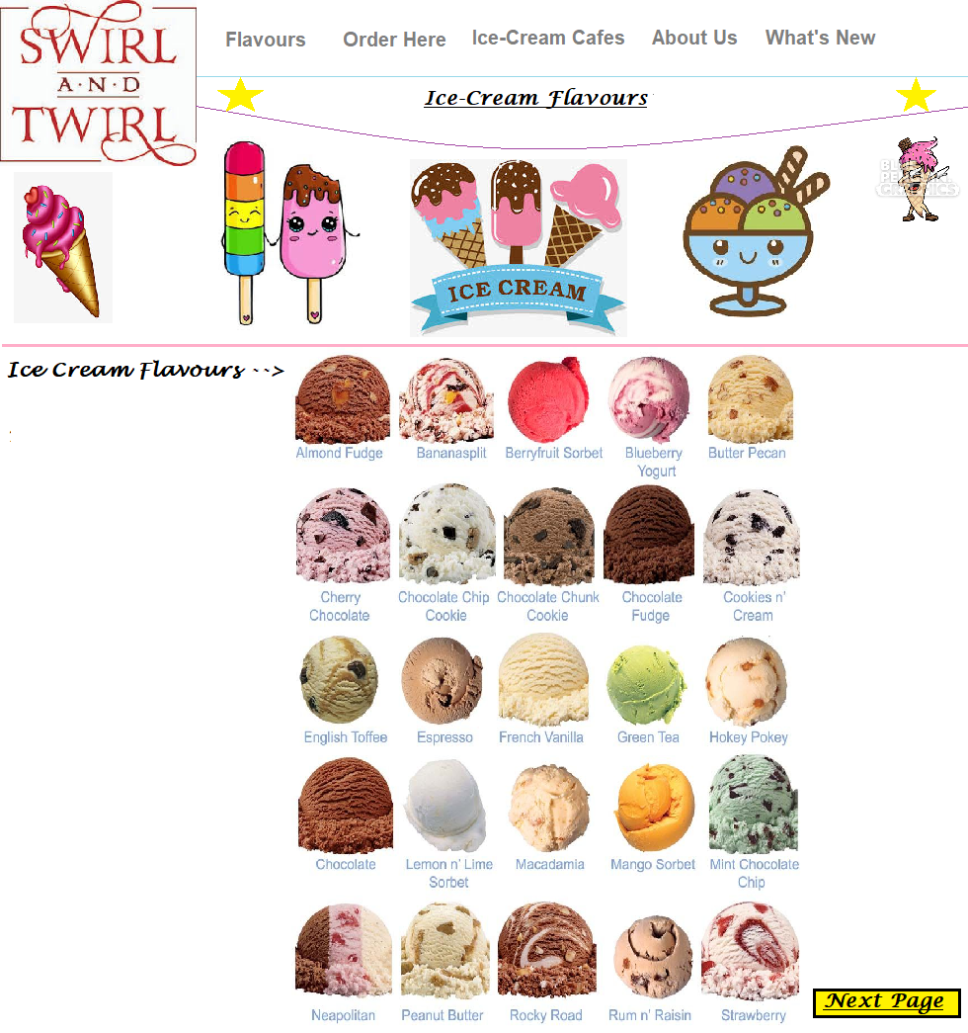

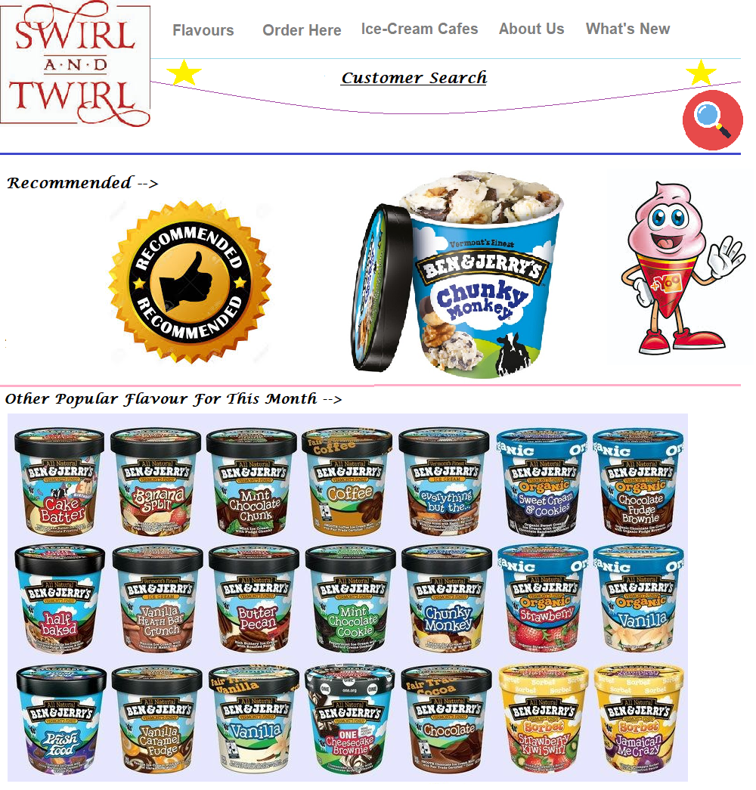

High Fidelity:

This was our near/finished website. From our other built up fidelities we were able to get a rough idea of what sort of direct or path we wanted the UI of the website to look at as well as its functionality aspect to it. Here are a few screenshots of some of the pages of our website down below:

**Functionality On Our Website**

Login/Registration Page:

We created a very user friendly login/registration page where we fuse both the login and registration using CSS (transitions). It follows the **create**, **read**, **update** and **delete** requirements to our website. Working alongside the CRUD element of our website is our database using SQLite (AJAX and JSON also used for asynchronous communication). This allows the users to sign up and login to our website. We incorporated some validation also to check the data inputted.

Advanced Search and Filter Mechanism:

This was added to our main page of our website. It lets the user search for anything available to them on the website. Our filtering mechanism shows specific items that a user might want to only display e.g. If a user selects “Ice-cream” they will get items that contain that selected item.

Usability/User Experience:

Our website is all about desserts especially ice-cream and cake! We wanted the user to experience and enjoy a UI which is beautiful visually and invokes a sense of happiness because after all everybody enjoys dessert! Error messages are present throughout the website particularly the login page. jQuery was also used for the transitions of the login/sign up page and the images in the banner cover for the index page. Bootstrap is included in the index page.

**Conclusion**

In conclusion we were pretty happy with the outcome of our project. We were able to fulfill a good majority into the project. We had a lot of fun making this project because we were our own creative genius when it came to picking a topic and UI design. Overall we are very happy with what we produced and can not wait to dive deeper into learning more about web development.